**Lesson03 Understand IList in c#**

**Notes:-**

**1-IList is non-generic collection object that can be individually access by index.**

**2-The IList interface has implemented from two interfaces and they are ICollection and IEnumerable. The definition of IList interface is like below.**

**Example:-**

**We see that we create IList of fixed size (it will create List of size 10 items with default value of zero)**

**static void Main(string[] args){**

**IList ilist = new int[10];**

**ilist.Add(10);**

**Console.ReadLine();}**

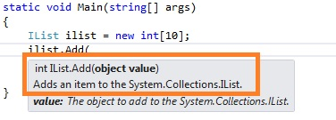

**//to store specific types inside list we can use the following expression**

**static void Main(string[] args){**

**IList ilist = new List<string>();**

**ilist.Add("10");**

**Console.ReadLine();}**

**Methods of IList**

**1-There are many methods in IList interface. Few of them are.**

**Add: - To add new object into IList**

**Clear: - To remove all the items from IList**

**Insert: - Insert one new object into IList collection to specific location.**

**Remove: - Remove the first occurrence of a specific object from the IList**

**RemoveAt: - To remove item at particular object from IList.**

**Properties of IList**

**Few popular property of IList interface is given below.**

**Count:- It will return number of object in List**

**IsReadOnly:- This property will indicate whether the IList is read-only or not.**

**Item:- It will return the particular Item of specified index.**